IMMC 2022 Winter—Problem D
Team Control Number: 22761451

“Efficiency is time and time is money” -- IMMC

Summary
Aircrafts are some of the most efficient way to travel on Earth. These huge machines can transport many passengers from one place to another in merely hours. The planes are efficient in the transporting; however, boarding and disembarking the plane takes tedious time. “In air transportation, efficiency is time and time is money.” The small delays cost by boarding and disembarking methods will cost the aircrafts and passengers to lose vauable time. From our research and modeling, we found out that such delays can be greatly shorten through the changing of methods.
Our team aims to find the optimal way of boarding and disembarking aircrafts. In this paper we will mainly focus on “Narrow Body” passenger aircraft, where there is one aicle and three seats on each side. We will also study two other aircrafts: the “Flying Wing” passenger aircraft, and the “Two Entrance, Two Aicle” Passenger Aircraft, and find the optimal boarding and disembarking method. Also, we will consider what will happen to the pandemic situation, where passengers will sharply decrease to only 70%, 50%, 30%. Finally, we will also write a letter to the Airline Excutive, to report our findings and give them some adivice in boarding and disembarking aircrafts.
Creating the boarding and disembarking method will be needing to know how much time each passenger takes to seat in. Then, find the passenger that needs the longest time to sit in. Caculating the time each passenger to board the plane involves caculating the speed, calculating the time waiting when people stops due to some reasons.
During our research and discussions, we have found out that the time of boarding and disembarking an aircraft depends on two main factors, lugguage placing, where passengers must stop to wait for one person to put in there luggage, and seat shuffle, where the passengers must be come out and “rearrange” to allow some passengers go in the inside seats.
Our goal is to find the most optimal way to board and disembark the aircraft. Time is important, but it is not the only consideration. Some methods are not practical in actual use, for example, the Steffen Perfect method. We will also consider factors like family, the number of groups needed, and rowdiness of the aircraft.
The optimal way will be considered through all of the factors above.

Contents
I. Summary 1
II. Introduction 3
III. Defining the Problem 3
3.1 Question restatement 3
3.2 Assumptions 3
3.3 Variables 4
IV. Modeling Boarding and Disembarking Aircraft 5
V. Narrow Body Passenger Aircraft 5
VI. Other Passenger Aircraft 9
VII. Pandemic Situations 11
VIII. Letter 11
IX. Strengths 12
9.1 Firstly, before our process in the actual formulation of the model, our team made lists of potential factors which would affect the total time needed for all the passengers to sit on the plane like the age, walking speed, strength, etc. Abundant research was done in order to make sure the statistics and data were all concise and accurate. A realistic model is strived to be achieved in order to provide the best boarding and disembarking method in real life; therefore, the correct numbers can ensure a flexible model which can be applied to many different scenarios. 12
X. Weaknesses 12
11 Appendix 13

Introduction
Efficiency, the state of working in a well-organized and competent way [3], is undoubtedly an important aspect during the boarding and disembarking of an aircraft. Due to various factors like accidents, delays, seating positions, and row numbers, the time needed in total for a plane to be completely seated would become increasingly long, which is an unwanted thing for those in a hurry. Therefore, in order to decrease and minus the possible time which can increase overall time needed, our team is to create a model which can find out the most efficient way in both boarding and disembarking a plane.

Defining the Problem

3.1 Question restatement
Our team is to complete five tasks:
- Calculate the total boarding and disembarking time and create a model which outlines the different aspects which can affect the time taken.
- Apply the model to the standard “narrow body” aircraft and, first, compare the boarding times for the boarding methods of random boarding, boarding by section, and boarding by seat. Second, we would need to analyze the how the times vary by differing numbers. Third, through the analysis and two additional boarding methods, explain the optimal boarding method and justify.
- Modify the model accordingly to the “Flying Wing” passenger aircraft and the “Two-entrance, Two-aisle” aircraft and recommend the most favorable boarding method for each kind of aircraft.
- Observe whether or not the boarding method would change if the number of passengers were limited to a specific percent.
- Write a one-page recommendation letter to an airline executive describing our results, recommendations, and rationale about passenger aircraft boarding and disembarking in a non- mathematical way.

3.2 Assumptions
In designing our model, we decided on several basic assumptions. Listed below are the assumptions and our justifications for them.
Assumption | Justification
Each passenger would take five seconds to lift one piece of luggage onto the overhead cabins. | We make this assumption because it is impossible to measure and predict the lifting strength of every passenger. In addition, by doing so, the function concerning the amount of time needed per passenger to stow away the luggage would be made easier due to the decrease in complexity which can make the overall process more understandable and efficient.
The passengers’ walking speed is only affected by their age and the weight of their carry-on bags | Due to the impossibility to measure the physical conditions of each passenger and how their walking speed is affected by those different factors, this assumption eliminates the things which cannot be calculated and leaves the things able to be searched in order to ensure that the numbers used would be accurate.
Children do not have any luggage | Since children have an average height of about 1.21m [1], it would be near impossible for them to lift their bags onto the overhead bins, therefore it would take up an unpredictable amount of time that is both unnecessary and unwanted in the model in case of messing up the calculation.
An infant is to be carried by an adult the entire time | FAA rules, and the airlines, do not require that infants and toddlers under the age of 2 be in a separate seat, [2], and therefore because of this, the infants do not take up one seat on the airplane, therefore they are assumed to be carried by the adult throughout the entirety of the flying session.
As long as the passenger reaches his or hers aligning row, he or she would go in without waiting people at the front to clear enough space for the person already sitting in the row to get out in. | First, it would be challenging to calculate the number of people at the back for each row in the aircraft, and second, to be realistic, it is possible to squeeze past the passenger, therefore enabling the exchange of position to get to the passengers’ seats accordingly.

3.3 Variables
T_{distance} | Time needed to go a certain row
T_{luggage} | Time needed for the passenger to lift one piece of luggage onto the overhead bins
T_{delay} | Time delayed due to passenger of smaller-numbered row stowing away luggage
T(p) | Function for the total time per passenger to walk towards corresponding row, stow away luggage, and sit on the seat

Modeling Boarding and Disembarking Aircraft

Narrow Body Passenger Aircraft

  - Time Needed for each Boarding Methods
The question requires us to apply our model to the following methods:
- Random (unstructured) boarding
- Boarding by Section: Examine varying the order of aft section (rows 23-33), middle section (rows 12-22), and bow section (rows 1-11).
- Boarding by Seat: In the order of window seats (A and F), middle seats (B and E), and aisle seats (C and D).
The factors that save time can be categorized into seat shuffle and luggage placing. In the following methods, only Boarding by Seat actually decreases some factors that affect time.
The first boarding method can be done by randomly generating the coordinates of the seat to each passenger. Running our code, rounding the numbers to a whole number, the results are the following:
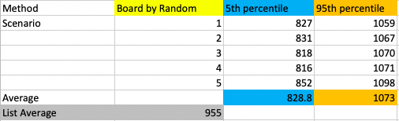

The second boarding method can be done by randomly generating the order which the passenger is going to the given rows of the seat. By this, each of the sections have an order in which the people in row 23-33 goes the first, the people in row 12-22 goes the second, the people in row 1-11 goes the last. The results are the following:
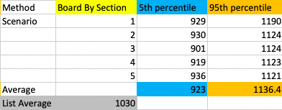

The third boarding method can be done by randomly generating the order which the passenger is going to the given columns of the seat (ABCDEF). By this each sections have an order of first passengers on the window seats A and F, then passengers on the middle seat B and E, at last passengers on the aisle seat C and D. The results are the following:
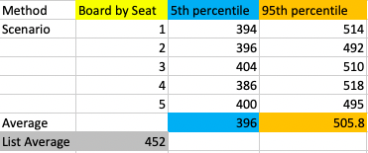

Comparing all of the data, we found out that the Boarding by Seat method is the fastest. In all, the results are the following:
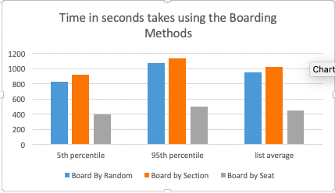

  - Sensitivity Analysis
It is common for people not following directions. When boarding a plane, chaos and disorder can all happen. Using the model, we have also recorded each method’s time needed when people who don’t follow directions percentage is at 10%, 40%, and 70%. The results are the following:

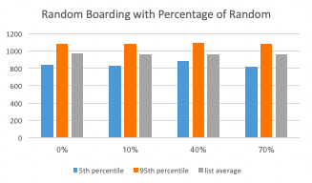
Boarding by random with the percentage of random didn’t change. It still levels at around the same place. It is easy to understand the results, as randomizing an already random sequence won’t change anything.

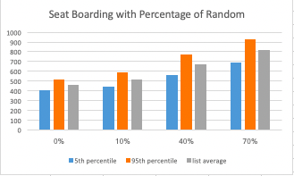
Boarding by seat have an increase of time needed, as the percentage of people who didn’t follow the rules increases. This means, that at a random rate, more seat shuffle appears.

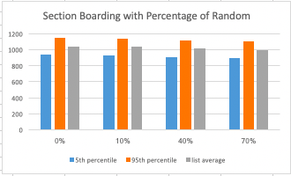

Boarding by section have a slight decrease as the percentage of people who didn’t follow the rules increases. Boarding by section is the slowest way. The slight decrease indicates that people will have a higher chance putting their luggage simultaneously when they are in a random order than in order.

The results are amusing. An order by section is worse than no order (random). This shows that the boarding methods must try to decrease the factors of seat shuffle and luggage placing, rather than putting everybody in an organized order.

  - Situation of More Luggage

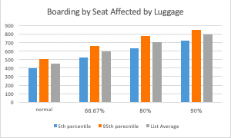
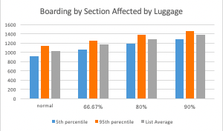
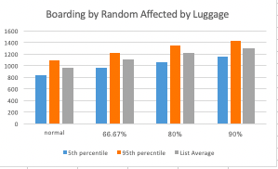
Many people might bring lots of luggage in order to save money from consignment. In this case, we have collected data at situation where two-thirds of people bringing luggage, four-fifths of people bringing luggage, and nine-tenths of people bringing luggage. The results are the following:
As more lugguage have been brought into the aircraft, the time it takes to board the aircraft gradually increases. People bringing their luggage is an act of saving money; however, this action also lowers the efficiency of boarding, and disembarking the aircraft.
  - Other Boarding Methods
Boarding Methods strengths and weakness can be summarized into 5 different elements:
- Luggage Placing: When a person places their luggage the whole line must stop.
- Seat Shuffle: When a person is blocking another person’s seat, they must come out and swap in order to let seat all the people.
- Family: Family need to be grouped together closely, so that children can be taken care.
- Groups: Numerous Groups can make the boarding very complicated.
- Rowdiness: Boarding in chaos may lower the efficiency.

- Steffen Method (which we are not using):
Met: Luggage Placing, Seat Shuffle, Rowdiness
The fastest way of boarding the plane is presented by Jason H. Steffen, called the Steffen method. This involves the line of people going into adjacent rows and putting their luggage simultaneously. Then, another line of people come in, putting their luggage simultaneously, etc.
This is the best way to avoid the problem of luggage placing, and seat shuffle. In fact, it is the fastest way theoretically. However, it cannot meet the requirement of Family Groups. This makes this method unpractical.
- Front back WMA Method
Met: Groups, Rowdiness, some Luggage Placing, some Seat Shuffle
This Method involves first dividing the airplane into front and back, and then divide the sections into window, middle, aisle seats. According to the order, back W, front W, back M, front M, back A, front A, the passengers sit in.
The dividing of groups isn’t complicated and very practical. It can also, in some way, it decreases the time needed to wait for luggage placing and seat shuffle.
The time it takes to board is _______ sec.

- Grouping Method
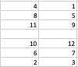
Met: Family, Seat Shuffle, Groups (the groups can be changed)
This method involves dividing the aircraft into sections. In this case, it is a 2 * 6. The people are sitting in this order (1 and 2 go in simultaneously, 3 and 4 also go in simultaneously, etc.:
The time it takes to board is ____ sec.
In all, our optimal boarding method is the Front Back WMA method.

  - Optimal Disembarking Method
Not much of the disembarking method are possible. We have chosen the fastest way, as disembarking the plane needs less a “family group”.
Line by Line Method:
When the plane lands, one person sitting on the aisle seats (C or D) of each row will come out and take their luggage. The person that come out on the first row will leave first, then the other five people on the same row will leave. The second row is the same as the first, and the pattern will be the same row after row until the people from the last row depart the plane.
This method is the fastest method: it avoids the situation of getting the luggage and seat shuffle.

Other Passenger Aircraft

6.1 Flying Wing Passenger Aircraft
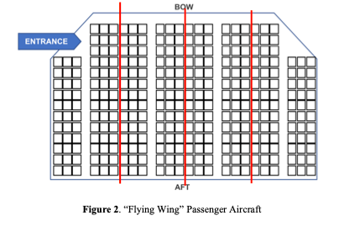
We have decided to divide the passenger aircraft into 4 narrow body passenger aircraft, and use the Front Back WMA method. The aircraft will be divided as below.
The aircraft will be divided into four “narrow body passenger aircraft. The farest will be seated first, then one adjacent to it, then the one that is adjacent to it, then the one that is cloest to the entrance.
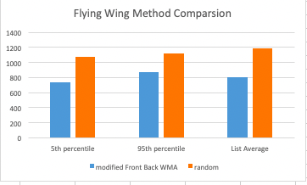
Using a model to estimate the time, we get that the method will need around 801 second. Comapring with random, this method is 389 second quicker. More detailed information are listed to the right:

For the disembarking method, we will still use the line by line method. We divides the passenger aircraft into four narrow body passenger aircraft, and then use the line by line method on all of the “narrow body passenger aircraft”.
The time it takes to disembark is _______ sec.
6.2 Two Entrance Two Aicle Passenger Aircraft
For the two entrance two aisle passenger aircraft, we have modified the Front Back WMA Method. First, we divide the whole airplane to the Royale class, front economic class, and back economic class. For the front economic class and back economic class, the seats will be further divided into aicle seats and “window seats” (the middle of the middle column of the seats counts as window seats). The royale class enters first. Then, the back and front economic class enters using the two entrances. In the order of window, aicle, the passengers seat in.
Using a model to estimate the time, we get that the method will need around 300 second. Comapring with random, this method is 35 second quicker. More detailed information are listed below:
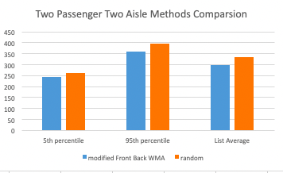

For the disembarking method, we will also, still use the line by line method. In this case, the whole aircraft will be leaving through two entrances, so it will be divided into front and back. It also have two aicles, so the passengers will leave on both two aicle, where at the last time, there is only one aicle needed.
The time it takes to disembark is _________ sec.

Pandemic Situations
Decreasing the amount of people to 70%, 50%, or 30% will allow more of the space on the aircraft to be used. By this we made a method to use up the extra space. First, the even number of rows will be seated at window and aisle seats. If there are more people, then the odd number of rows will be seated at window and aisle seats. If there are still more people that haven’t been seated, then, they will seat in the middle seats of each row. By this way the space can be most reasonablely used, and also keep the most space between people and people.

Narrow Body Passenger Aircraft:
Flying Wing Passenger Aircraft:
Two Entrance, Two Aisle:

Letter
To the Airline Executive,
As the times change, fast transportation has become an important aspect needed to be achieved in order to ensure both efficiency and timeliness, and travelling by plane is undoubtedly the fastest way for movement for the people. Therefore, executive, our team has divided the process of being on a plane into three categories: boarding, the flying time, and disembarking periods, and since the flying time cannot be decreased since the legal cruising speed is between 550 and 580 mph [5], we layered out the different boarding and disembarking methods, and which after we observed and ran simulations taking specific details into account and comparing both the disadvantages and advantages of each, got the optimal boarding and disembarking methods for the standard narrow-body plane.
For boarding, the method which our team designated, the Front Back WMA method, is the best way, considering both practicality and efficiency. It divides the passengers into six groups: back window, front window, back middle, front middle, back aisle, and front aisle. The groups would enter the plane chronologically in the order as it was listed above. After simulation, our team found out that it was the method which took the least time apart from random (which we did not include due to the excess amount of rowdiness which would ensure shortly after boarding), and also had benefits like a small number of groups, making it easier to understand, and the evident lack of rowdiness, thereby maintaining the aircraft’s order. By using this method, both efficiency and the practicality of it actually being followed by the majority is balanced out.
For disembarking, the best way was the Line by Line method, easy to understand and enforce. It is divided upon the rows, where the people in the front row would get out, first the aisle seats, then the middle seats, and afterwards the window seats. The process would repeated for each row behind the empty ones, until the entire plane is evacuated. By doing so, the people’s luggage would be easy to find and carry. There would not be people trying to go past the other, and families would stay together in a closer unit.
In conclusion, executive, please know that our team has worked hardly and in detail, considering almost all of the details in which could delay the boarding and disembarking processes. The two methods, Front Back WMA, and the Line by Line method, are a combination of both timeliness and the realistic aspect of the method. Therefore, rest assured to apply those methods as the boarding and disembarking ways for the standard narrow body plane. Thank you!

Regards,
Team 22761451

Strengths

9.1 Firstly, before our process in the actual formulation of the model, our team made lists of potential factors which would affect the total time needed for all the passengers to sit on the plane like the age, walking speed, strength, etc. Abundant research was done in order to make sure the statistics and data were all concise and accurate. A realistic model is strived to be achieved in order to provide the best boarding and disembarking method in real life; therefore, the correct numbers can ensure a flexible model which can be applied to many different scenarios.
9.2

Weaknesses
  - We assumed that the time for one passenger to lift one piece of luggage onto the overhead cabins to be five seconds. However, it is evident that in real life different people’s strength vary, so by making the assumption the model may be reduced in the realistic aspect. However, albeit this assumption, the model would still be more accurate than if we simply “guessed” the time needed for each passenger to lift their luggage.

Appendix
[1] “Average Child Height | Onaverage.co.uk.” Onaverage.co.uk, 2019, www.onaverage.co.uk/body-averages/average-child-height.
[2] Harvey, Author Leslie. “What to Consider before Flying with a Lap Child.” Trips with Tykes, 22 May 2013, tripswithtykes.com/should-you-buy-a-seat-for-your-child-under-age-2/. Accessed 10 Mar. 2022.
[3] “EFFICIENT | Meaning & Definition for UK English | Lexico.com.” Lexico Dictionaries | English, www.lexico.com/definition/efficient. Accessed 11 Mar. 2022.
[4] Cimler, R. & Olše􏰁ičo􏰁á, K. Analysis Simulation of aircraft disembarking methods, AWERProcedia Information Technology & Computer Science. [Online]. 2013, 3, pp 867-872. Available from: http://www.world- education-center.org/index.php/P-ITCS. Proceedings of 3rd World Conference on Information Technology (WCIT-2012), 14-16 November 2012, University of Barcelon, Barcelona, Spain.
[5]

